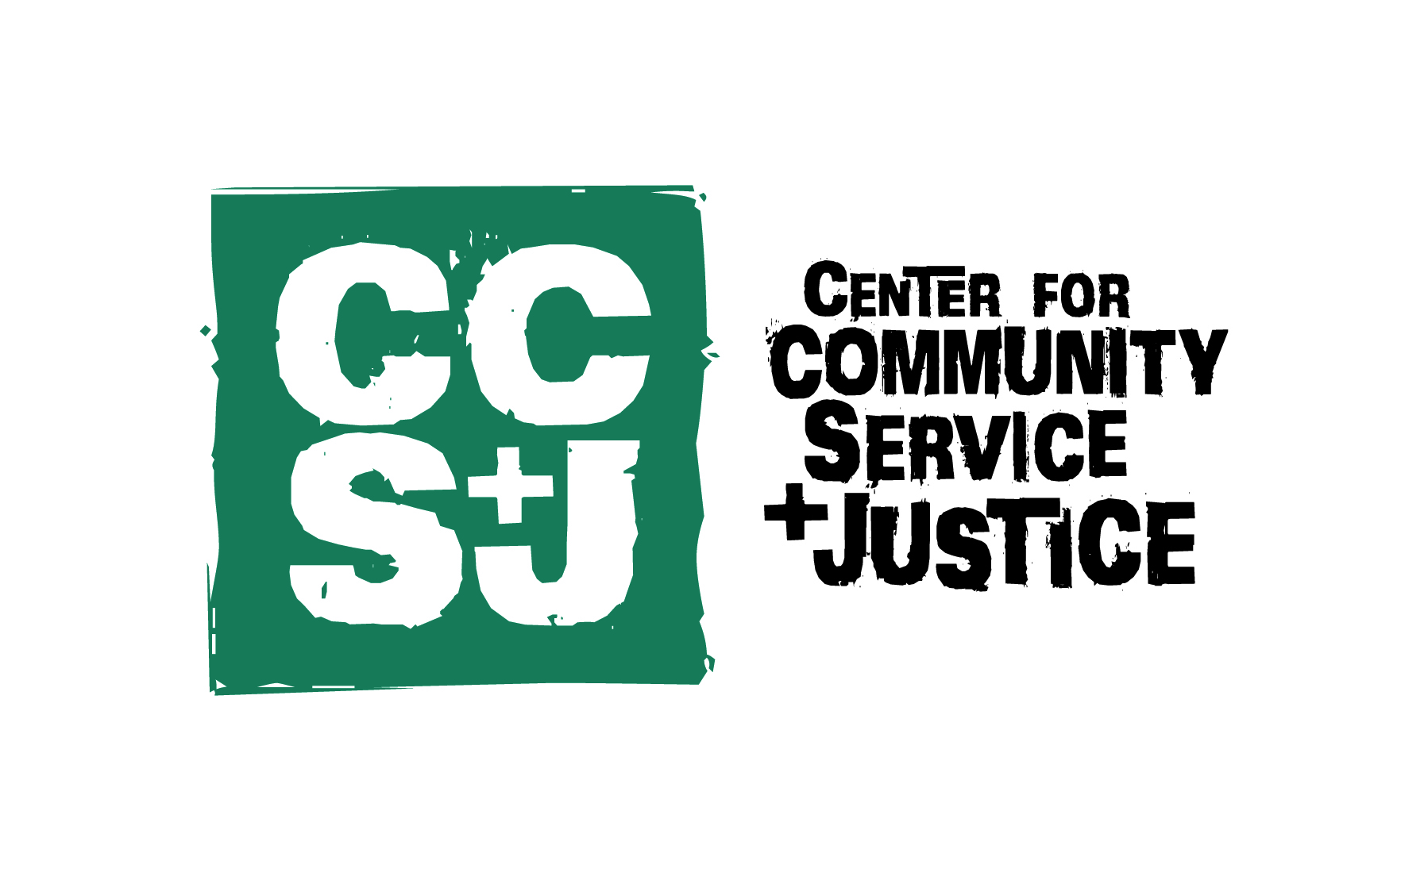

Dear Faculty Member,

You are cordially invited to participate in the Faculty Fellows Seminar on Service-Learning and Engaged Scholarship at Loyola University Maryland. The Faculty Fellows Seminar is an opportunity to learn about service-learning pedagogy and integrate it into an appropriate course in the company of friends and colleagues from a number of departments. It is also an opportunity to learn about other types of engaged scholarship in addition to service-learning.

Faculty Fellows:
- investigate the theories and models of learning behind service-learning;
- discover how others have successfully integrated service-learning into their own disciplines and courses at Loyola and at colleges and universities nationally and internationally;
- meet community partners and explore reciprocal partnerships;
- inquire into methodologies of assessment and evaluation;
- explore ways to use structured reflection to integrate diverse forms of learning;
- provide and receive feedback on course development in interactive small groups;
- explore issues of racial justice, social identity, privilege, and power;
- learn about various forms of engaged scholarship in addition to service-learning; and
- find out how to integrate service-learning into their teaching in ways that comply with Loyola’s nationally recognized service-learning course designation standards.

Seminar Meeting Times and Dates:
The seminar takes place during five sessions scheduled throughout the spring semester, with a final wrap-up day scheduled for the Tuesday of Welcome Week (the week before the start of classes) in August. Meetings during the spring semester take place every 2-3 weeks and are scheduled when participants are available.

Eligibility: All full-time, continuing faculty are eligible to participate
Registration Deadline: Friday, December 6
Seminar Limit: 15
Guest Fellows: Up to five faculty from neighboring colleges and universities are invited to participate as Guest Fellows, if space is available.

Seminar Readings and Integration Project
Course readings made available on Moodle will guide seminar conversations and individual inquiry. In addition, each Fellow commits to: (a) integrating service-learning into one course; (b) applying to have that course designated as a service-learning course; (c) teaching the course at least once during the next two years; and (d) serving as a departmental mentor and advocate for service-learning and engaged scholarship.

Following the five spring-semester sessions, Fellows have the rest of the summer to work individually on their service-learning Integration Projects. During the last seminar meeting at the end of August, Fellows present their service-learning courses and syllabi to one another and invite constructive review and feedback from their colleagues in the seminar.

The Integration Project requires Fellows to understand basic criteria for service-learning courses, select an appropriate course, develop learning objectives for service-learning in the course, identify appropriate community partners (agencies, schools, businesses), and integrate service-learning (including structured reflection, evaluation, and assessment procedures) into the syllabus. Allen Brizee is happy to assist Fellows in their efforts over the summer and during the academic year.

If you are interested in participating in the Faculty Fellows Seminar, please complete the accompanying registration form by the Friday, December 6, and return it to Allen Brizee in the Center for Community Service and Justice in Humanities 142 or via email to CELS@loyola.edu.

Contacts and for more information:
Allen Brizee, Ph.D., Faculty Director of Community-Engaged Learning and Scholarship and Professor of Writing, habrizee@loyola.edu
General inquiries may be sent to CELS@loyola.edu.

Faculty Fellows Seminar:
Service-Learning and Engaged Scholarship

Registration Form

Name _____________________________ Department ______________________________

Phone Number _____________________ Email Address ____________________________

Course into which I plan to integrate service-learning (I understand that I can substitute another course as I learn more about service-learning during the seminar):

Course Number and title: _________________________________________________________

Semester Course Will Be Taught: _______________________________________________

I wish to participate in the Faculty Fellows Seminar on Service-Learning and Engaged Scholarship and can attend all seminar meetings. I agree to: submit a completed service-learning course syllabus to Dr. Allen Brizee, Faculty Director of Community-Engaged Learning and Scholarship, for designation at the completion of the seminar in August, and teach this course as a designated service-learning course at least once during the coming academic year. My department chair’s signature indicates his/her agreement to schedule the course during the next academic year.

____________________________________________________ __________________
Signature Date

____________________________________________________ __________________
Signature of Department Chair Date

____________________________________________________ __________________
Signature of Dean Date

Registration Deadline: Friday, December 6, 2019
Please complete and return this form to the Center for Community Service and Justice (campus mail)
or via email to CELS@loyola.edu

